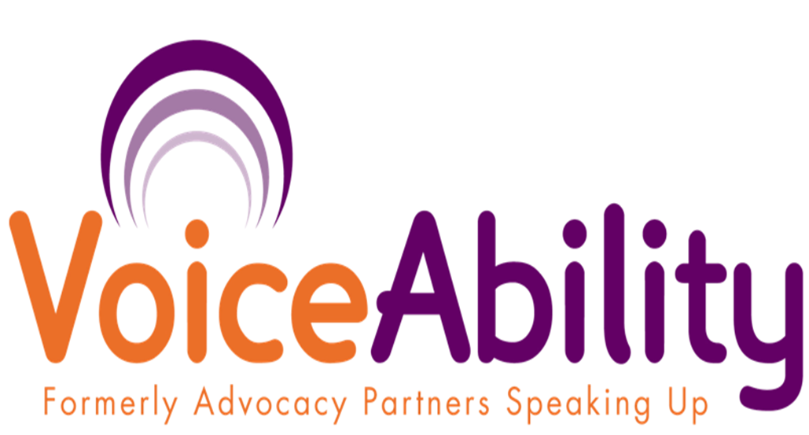
VOICEABILITY

IMCA REFERRAL FORM

VoiceAbility can provide an Independent Mental Capacity Advocate (IMCA) to people who are physically in areas that VoiceAbility is commissioned to provide IMCA, when a decision is being made about either their:

1) Serious medical treatment or
2) Long term move (more than 28 days into hospital / 8 weeks into a care home)

and it is considered that the person does not have the capacity to make that decision
and they have no family or friends ‘appropriate’ to consult with

We may also be able to provide an IMCA where a person lacks capacity to agree to arrangements in;

3) Care reviews where there are no family or friends able to support and represent the person.

4) Adult protection proceedings, where the person is victim or alleged perpetrator, regardless of family and friend involvement

Section 1 – Personal Details
1 | Referred person’s full name |  |  | Date of Birth |  | M |  | F |  | Funding Local Authority
2 | Usual address |  |  |  |  |  |  |  |  |  | Postcode
2 | Usual address | Phone |  |  |  | Local Authority
3 | Address at now, if different to usual address |  |  |  |  |  |  |  |  |  | Postcode
3 | Address at now, if different to usual address | Phone |  |  |  | Local Authority
4 | Ethnicity | White British |  | Black Caribbean |  | White/Asian |  | Indian
4 | Ethnicity | White Irish |  | Other Black background |  | Other mixed back ground: |  | Other Asian background
4 | Ethnicity | Other white background |  | White/Black Caribbean |  | Bangladeshi |  | Chinese
4 | Ethnicity | Black African |  | White/Black African |  | Pakistani |  | Other (please state)
5 | Client Group | Learning disability |  | Autistic Spectrum Disorder |  | Mental Health needs |  | Serious physical illness
5 | Client Group | Dementia |  | Acquired brain injury |  | Unconscious |  | Other (please state):
6 | Primary communication | English |  | Other language: |  | Gestures/ vocalisations/ facial expressions |  | Other (please state):
6 | Primary communication | Pictures/symbols/  Makaton |  | BSL |  | No obvious communication

Section 2 – Case Details
7 | Decision to be made: | Adult protection proceedings are being instigated |  |  | Long term move |  |  |  | Accommodation review |  |  |  |  | Serious medical treatment
8 | Person lacks the capacity to make the decision in Q7: | A Mental Capacity Act test has been done by the decision-maker |  |  |  |  |  |  | A Mental Capacity Act test has been done by another professional but decision maker agrees the person lacks capacity to make this decision
9 | When does the decision need to be made? | Please list deadlines and meeting dates:
10 | Decision-makers (DM) recommended cause of action?
11 | Are there friends/family? | Yes, but this is an Adult Protection Proceedings referral |  |  |  | There are no family/friends |  |  |  |  |  | Yes, but DM considers they are not ‘appropriate’ to consult
12 | Please clearly state reason(s) why family / friends are considered not ‘appropriate’ to consult.
13 | Please ensure family/friends are informed of the involvement of an IMCA | I have informed the family/friends of IMCA involvement |  |  |  |  |  |  |  | I will inform the family/friends of IMCA involvement
14 | Please list contact details of relevant people e.g. Decision maker (if not referrer) G.P, Care Manager, Key worker, Day centre etc
15 | Risks to personal safety – Detail any information needed to ensure the safety of the advocate and the referred person, including risk management procedures in place:

Section 3 – Referrers’ Details
16. Referrers’ Name |  | Referrers’ Team
Relationship to referred person; (E.g. Care Manager, GP, social worker, consultant)
Address
Email address |  |  | Telephone
How did you hear about this service? |  |  | Are you the decision maker? |  |  | Yes | No (DM details given in box 14)

17. I would like VoiceAbility to provide an IMCA. They can keep, and put on computer the information on this form, and other information I provide needed to do the work.
I am providing this information and asking for this referral in the referred person’s best interests and in line with the Mental Capacity Act.
I consider that the referred person lacks the capacity to make the decision referred for and has no family/friends ‘appropriate’ to consult with / this is an Adult Protection Proceedings referral (delete as appropriate)
Referrers Signature (if not DM) |  | Date
Decision Makers signature |  | Date
Please Return to: IMCA, VoiceAbility, McMillan House, 54 Cheam Common Road, Worcester Park, Surrey KT4 8RH.
Fax: 0208 330 6622 Email: imca@voiceability.org IMCA Hotline: 08450 175 198

********** Please call the hotline after sending referral to ensure it has been received **********

