The purpose of this guideline is to support a systematic & safe approach to patient care before, during and after they have been turned into the prone position. Further guidance and references are available in the Prone Position resource folder.
PRE-TURN INTERVENTIONS | COMMENTS
PATIENT ASSESSMENT: include CXR, ECG & pupil response
ACCESS: Functional? Required? Exit Site? Dressing? | Dressing changes, line removal and line insertion will be difficult to achieve once prone
HYGIENE: Ensure front of patient cleansed prior to pronation.
PRESSURE AREAS:  -Assess & Document skin integrity. Pay close attention to face, chest, breast (F), iliac crests, genital (M), knees, tips of toes. Photograph any areas of concern.  -Consider use of dermal pads. | Very high risk of skin breakdown. Again, need to anticipate potential problems and incorporate strategies to reduce risk to patient.
Stoma Care – empty bag & consider drainage devices. | Pre-empt difficulties caused by burst stoma bags…
EYE CARE:  Clean, Lubricate (Simple eye ointment) &Tape shut.  ENSURE EYES ARE CLOSED | *High risk of corneal abrasion in prone position due to improper closure of eyes and contact with bed.  *High risk of cross infection to eyes due to increased drainage of oral secretions.  *Eyes will be more difficult to access making it problematic to deliver good standard of eye care.
MOUTH CARE:  Brush teeth. Lubricate Lips. | Mouth will be difficult to access once proned.
EXPLAIN procedure to pt and family.
AIRWAY:  - Ensure ETT/tracheostomy well secured.  - Document length @ lips, tube size & grade of intubation.  - Ensure re-intubation equipment and anaesthetist readily available. | High risk of tube becoming dislodged therefore good practices must be meticulously observed.
INVASIVE LINES:  -Secure? Enough ‘slack’ on lines?  - Arrange lines to top of bed. | Ensures that lines will not get ‘snagged’ during turn
CHEST DRAINS:  - Do not clamp.  -Arrange drain tubes to bottom of bed.  -Allocate team member to manage drain(s) | Ensures that drains don’t kink, disconnect or migrate.
NG TUBE:  - Secure NG Tube – ensuring gap at nare.  -Aspirate NG Tube  - Document length at nare & pH of aspirate.  - STOP FEED for duration of turn. Confirm position of tube before restarting feed. | Risk of aspiration increased during turn and for duration of prone.
ANALGESIA/SEDATION/PARALYSIS | Likely to have high analgesia/sedation requirements.

PRE-TURN INTERVENTIONS (Cont) | COMMENTS
MONITORING:  - Ensure ECG dots removed from chest  - Audible SpO2monitoring  - EtCO2 monitoring  - Alarms set and turned on. | Consider using portable EtCO2monitoring if insufficient ‘slack’ on conventional monitor.
PRACTICALITIES:  - Prone Team should consist of a minimum of 5 people including an anaesthetist or senior nurse to manage airway.  - Ensure white sheet and 2 sliding sheets underneath patient.  - Place pillows onto chest, hip, knees.  - Pre-oxygenate & suction.  - Consider fluid loading  - Wrap patient using ‘Cornish pasty’ technique. | It is beneficial to involve practitioners who are experienced in this procedure.  Liaise with medical team: De-recruitment & fluid shifts may result from manoeuvre.  See You Tube video available on ICU/HDU computer desktop.

POST- TURN INTERVENTIONS | COMMENTS
Immediate:
Check patency & security of AIRWAY.
Re-establish monitoring
Position patient’s head and arms into ‘swimmer’s position’.
Place absorbent pad under head | Drainage of oral secretions may increase. This intervention allows easy removal of any soiled materials.
Place bed into reverse trendelenburg position | Reduces facial and peri-orbital oedema.
Ongoing:
MOUTH CARE:  -Mouth care using 1% chlorhexidine gel & oro-pharyngeal suctioning as able. Document.  -Closely observe lips/chin for pressure damage. | Drainage of oral secretion will increase when prone.
EYES;
-ENSURE THAT EYES ARE CLOSED & FREE FROM DIRECT PRESSURE.
-Eye care as able. Document.
NASO-GASTRIC FEEDING:  -Ensure strict adherence to 4 hourly aspirates and position checks.  -Consider prokinetics early if high aspirates found. | It has been suggested that prone positioning places the patient at greater risk of aspiration secondary to delayed gastric emptying when prone therefore feeding should be managed with GREAT VIGILANCE.
LIMB CARE &POSITIONING:  - Liaise with physiotherapy for individualised plan of care.  - Nurse in ‘swimmer’s position’. Modify position of arms and head 2-3 hourly.  - Consider use of gel ring to position patient’s head. | Patients still need to be mobilised in this position to avoid loss of function to muscles & joints.

SUGGESTED DAILY TIMETABLE DURING PRONE POSITIONING
09.00 | Unprone
09.30 | Medical & Nursing Assessments: CXR, ECG, Review access & wounds
10.30 | Physiotherapy
11.00 | Visiting
12.30 | Assist with hygiene
13.30 | Visiting
15.00 | Prone – 16 hours duration

SWIMMERS’ POSITION
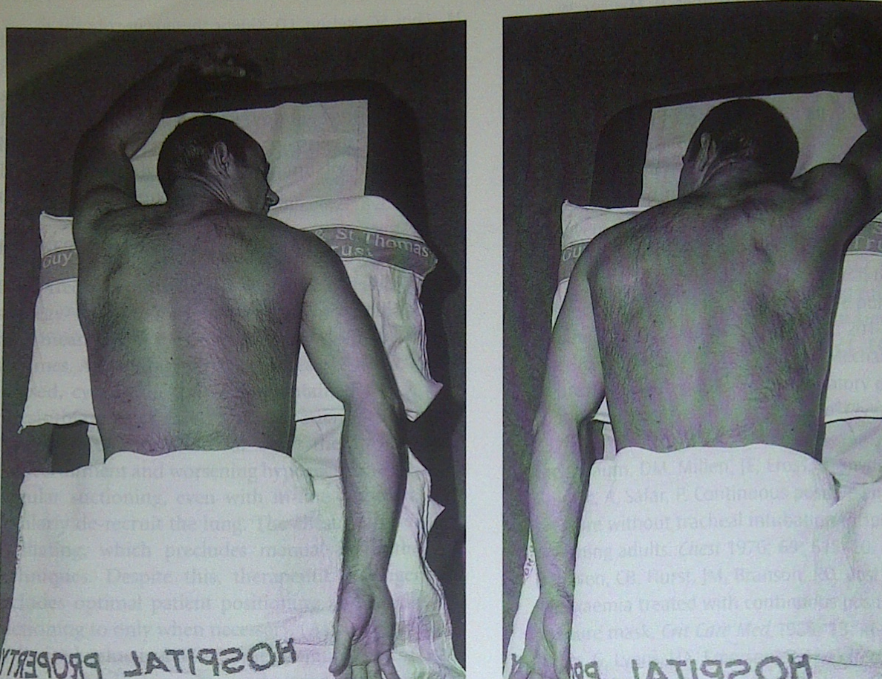
Craig Davidson and David Treacher 2002 'Respiratory Critical care'. P.78
Approved: November 2014 Review date: November 2019

